# Web Engineering

# Assignment 2

**Total Marks: 40**

**Due Date: 13 April, 2023**

**Instructions:**

1. *Submit a code online.*
2. *Individual Assignment.*
3. *Late submission will cause you to lose 10% per day. After three days of deadline no submissions will be entertained.*
4. *Copied assignments will get straight ZERO.*
5. *There will be a quiz based on assignment in the very next class of the submission date.*

**Question 1:**

Create following 2 different page.

Create Task 1 with div – float property

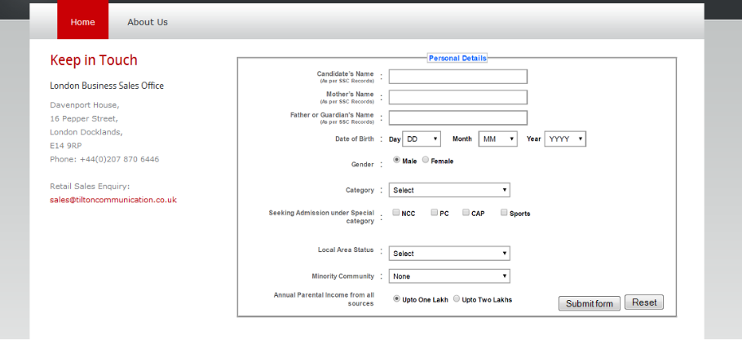

Create Task 2 with div – flex property

